**DANCE THEATRE OF HARLEM TO HONOR DARREN WALKER AT 2025 VISION GALA**

*Filmmaker and Producer Ava DuVernay to Present the Arthur Mitchell Vision Award to Ford Foundation President Darren Walker*

*Dance and Film Legend Ben Vereen to Honorary Chair*

*DJ D-Nice and Kenny Burns to Provide Entertainment*

*The Gala is part of the 2025 Season at New York City Center Featuring Four Standout Performances Including a World Premiere*

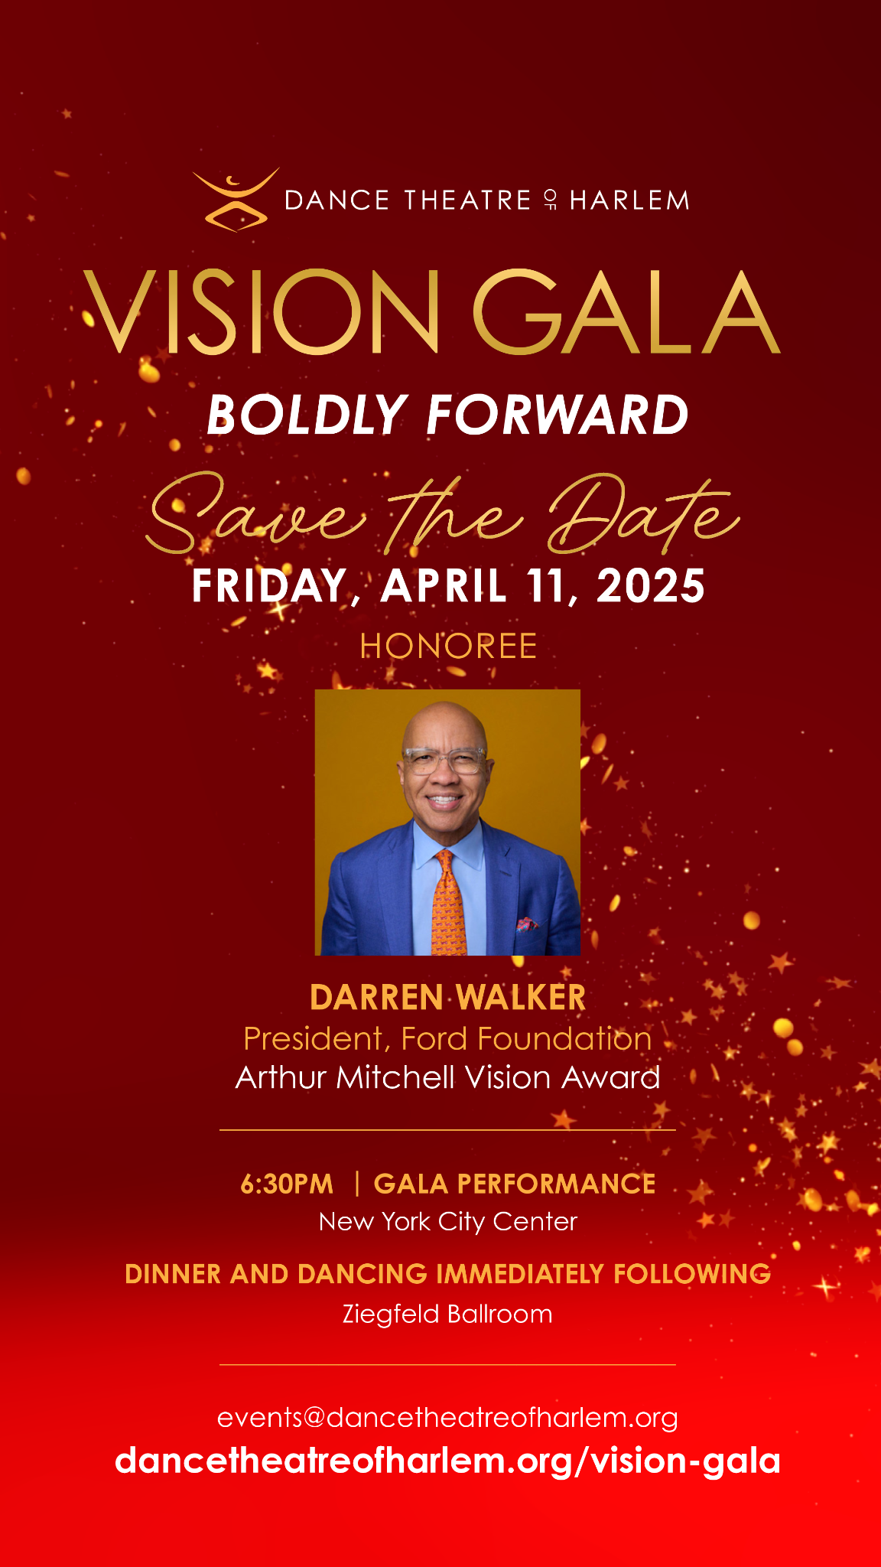

**(New York, NY) February 11, 2025** - The world-renowned **Dance Theatre of Harlem** (DTH) will return to New York City Center to host its annual Vision Gala on Friday, April 11, 2025.

Each year, DTH honors individuals and leaders whose work and practice parallel that of DTH co-founder Arthur Mitchell. This season’s gala will be a fundraiser supporting the organization’s programmatic season as well as Dance Theatre of Harlem School. This year’s honoree will be Ford Foundation President **Darren Walker**. Presenting him with the *Arthur Mitchell Vision Award* will be award-winning filmmaker and producer, **Ava DuVernay**. DuVernay will also serve as a co-chair for the event, where she will be joined by the likes of **Ursula Burns**, **Agnes Gund** and dance and film legend **Ben Vereen**. Handling entertainment for the evening will be **DJ D-Nice** and entertainer **Kenny Burns**.

This joyous event will begin at the New York City Center with tribute performances by the Dance Theatre of Harlem company, in honor of arts advocate and philanthropist Darren Walker, including a special presentation of *We Are All Brown – Commemorating Brown v. Board of Education* with Oration by Legal Defense Fund President and Director-Counsel Janai Nelson*.* Following the performances will be dinner and dancing at the iconic Ziegfeld Ballroom. Previous honorees include Debbie Allen, Misty Copeland, and Grammy award-winning opera singer Jessye Norman, to name a few.

For Vision Gala tickets and more information, email events@dancetheatreofharlem.org.

The gala is part of Dance Theatre of Harlem’s 2025 New York season which is set to include four standout performances led by DTH artistic director, Robert Garland. The artistic offerings are brimming with world premieres, New York premieres and company premieres. See more details below.

**Thursday, April 10 at 7:30pm**

Dance Community Night

*The Cookout* (NY Premiere) - Robert Garland

*The Vertiginous Thrill of Exactitude*(Company Premiere) - William Forsythe

*The Passage of Being* (World Premiere) - Jodie Gates

*Donizetti Variations*(Company Premiere) *-* George Balanchine

**FRIDAY, APRIL 11 at 6:30pm**

**Vision Gala Performance**

*The Vertiginous Thrill of Exactitude* (Company Premiere) - William Forsythe

*Excerpts from Donizetti Variations* (Company Premiere) - George Balanchine

*We Are All Brown* – Commemorating *Brown v. Board of Education* with Oration by

Jenai Nelson, President, Legal Defense Fund

**SATURDAY, APRIL 12 at 7:30pm**

**Divine Nine/HBCU Night**

*Return* - Robert Garland

*Donizetti Variations* (Company Premiere) - George Balanchine

*The Passage of Being* (World Premiere) - Jodie Gates

The Cookout (NY Premiere) - Robert Garland

**SUNDAY, APRIL 13 at 3pm**

**Meet the Ballerina Matinee**

*The Cookout* (NY Premiere) - Robert Garland

*The Vertiginous Thrill of Exactitude* (Company Premiere) - William Forsythe

*The Passage of Being* (World Premiere) - Jodie Gates

*Donizetti Variations* (Company Premiere) - George Balanchine

**About Dance Theatre of Harlem**

**Dance Theatre of Harlem** is a leading dance institution of unparalleled global acclaim, encompassing a world class company, a professional studio school, a leading arts education program - Dancing Through Barriers®, and community engagement activities. Each component of Dance Theatre of Harlem carries a solid commitment towards enriching the lives of young people and adults around the world through the arts. Founded in 1969 by Arthur Mitchell and Karel Shook, Dance Theatre of Harlem was considered “one of ballet’s most exciting undertakings” (*The New York Time*s, 1971). Shortly after the assassination of The Reverend Dr. Martin Luther King, Jr., Mitchell was inspired to start a school that would offer children — especially those in Harlem, the community in which he was born — the opportunity to learn about dance and the allied arts. Now in its fifth decade, Dance Theatre of Harlem has grown into a multi- cultural dance institution with an extraordinary legacy of providing opportunities for creative expression and artistic excellence that continues to set standards in the performing arts.

For more information about Dance Theatre of Harlem, visit [www.dancetheatreofharlem.org](http://www.dancetheatreofharlem.org).

Follow Dance Theatre of Harlem on Instagram and Facebook: @DanceTheatreOfHarlem; and YouTube: Dance Theatre of Harlem.